GROUP NO. :

FY B.TECH CS

CYBERSECURITY

KARAN SURYAWANSHI - 201070064

JAY SAWANT -

AMEY BHATUSE -

**LAB ASSIGNMENT - 2**

**AIM :** Perform two/three attacks on from each layer of TCP/IP

**THEORY :**

**WHAT IS TCP/IP MODEL ?**

**→** TCP/IP Model helps you to determine how a specific computer should be

connected to the internet and how data should be transmitted between them. It

helps you to create a virtual network when multiple computer networks are

connected together. The purpose of the TCP/IP model is to allow communication

over large distances.

TCP/IP stands for Transmission Control Protocol/ Internet Protocol. TCP/IP

Stack is specifically designed as a model to offer highly reliable and end-to-end

byte stream over an unreliable internetwork.

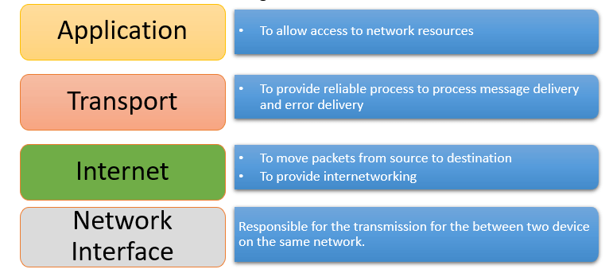

1. **APPLICATION LAYER :**

The application layer in the OSI model is the closest layer to the end user which means that the application layer and end user can interact directly with the software application. The application layer programs are based on clients and servers.

Common application layer attacks might include :

1. **HTTP FLOOD DDOS ATTACK :**

What is an http flood ddos attack ?

→An HTTP flood DDoS attack utilizes what appear to be legitimate HTTP

GET or POST requests to attack a web server or application. These flooding DDoS attacks often rely on a botnet, which is a group of Internet-connected computers that have been maliciously appropriated through the use of malware such as a Trojan Horse.

**IMPLEMENTATION :**

For this attack we have used two virtual machines

1) Attacker Machine: Kali Linux

2) Victim Machine: Redhat Linux

First we find the IP Address of Client machine using ifconfig command:

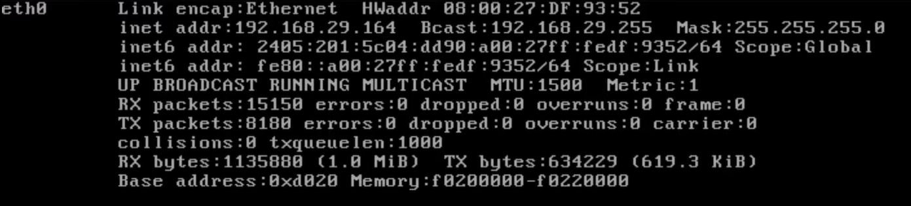

IP Address of victim machine: 192.168.29.164

On Victim machine we have an HTTP server running.

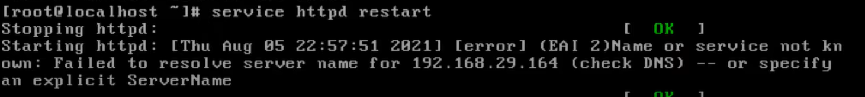

On attacker machine we can see the website by typing the ip address of victim machine

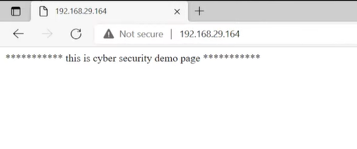

To perform the attack we are going to use the slowris.pl tool . We downloaded the tool file from github and gave all permissions using the chmod command.

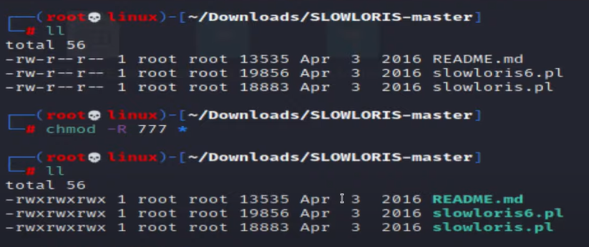

Then we started the attack by using perl command to run slowris.pl file and providing victim

IP.

● perl slowris.pl -dns 192.168.29.164

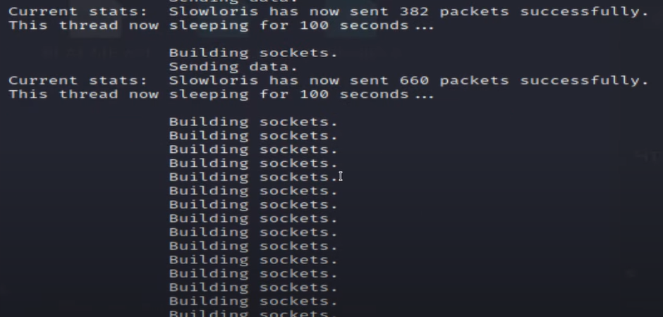

The attack has started and the attacker machine is now sending lot of HTTP requests to the server

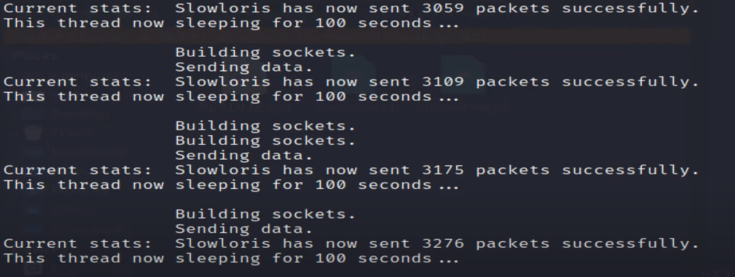

Now when we try to open the website we get no response from the web server



1. **DNS CACHE POISONING :**

Before performing DNS spoofing we need a clear idea about DNS. DNS stands for Domain Name System. Domain Name System or DNS server translate a human-readable domain-name (such as google.com, nytimes.com) into a numerical IP address that is used to route communications between nodes. As we know every system have an unique IP address, but it is very difficult to remember the IP address of many websites for a human. So a domain name attached with the IP address. To reduce the effort and improve the performance DNS saves translate data for a limited time which is called cache. This means if it receives another request for same translation, it can replay without needing to ask any other servers until the cache expires.

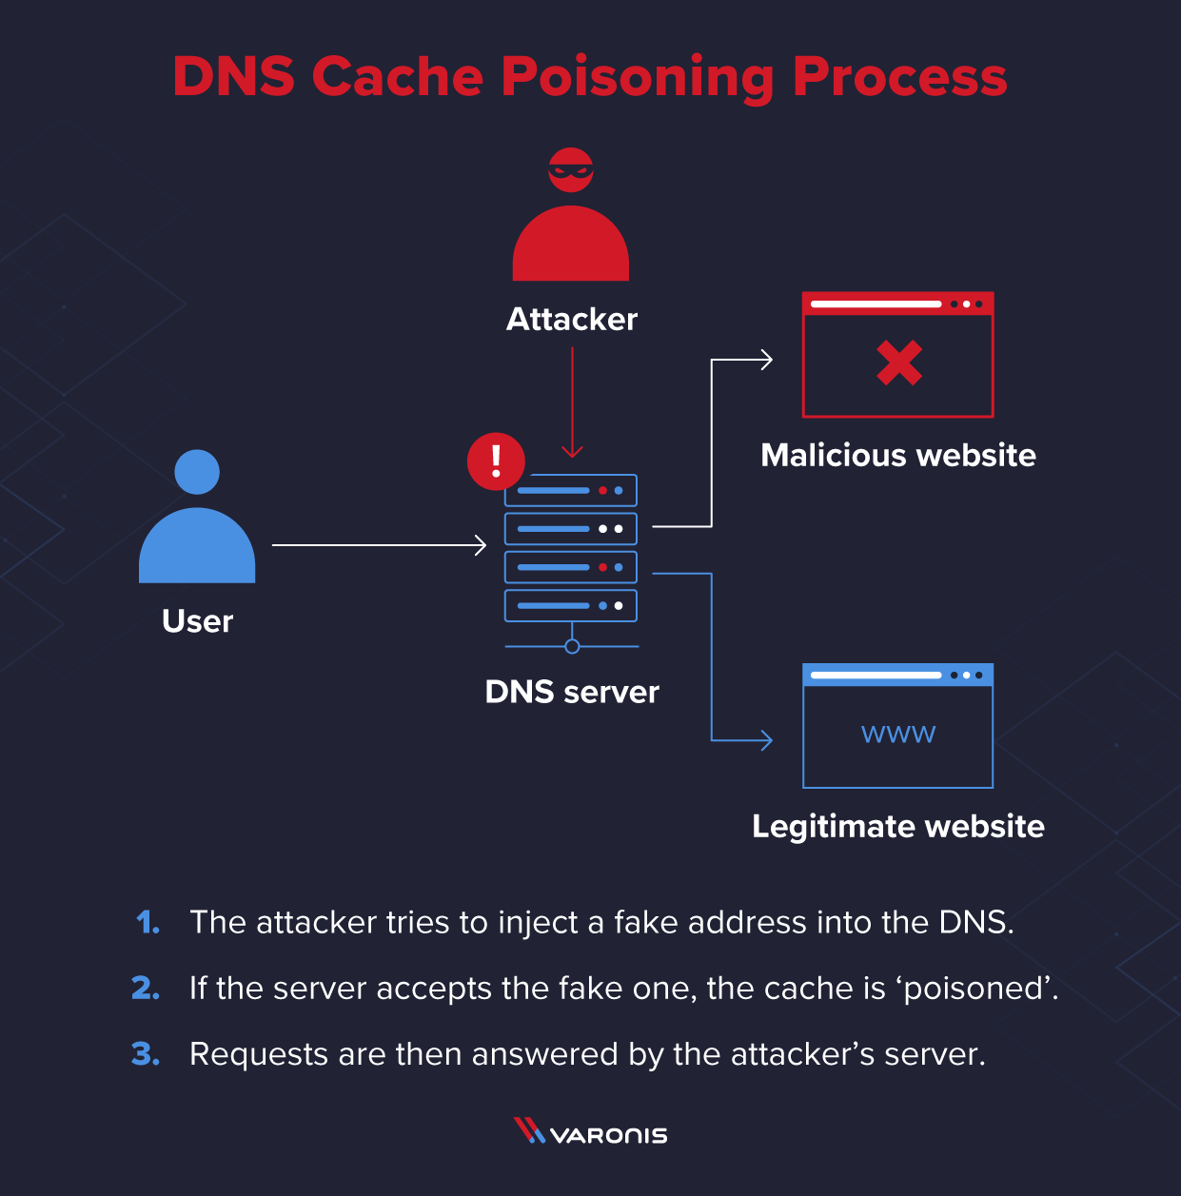

DNS cache poisoning is the act of entering false information into a DNS cache, so that DNS queries return an incorrect response and users are directed to the wrong websites. DNS cache poisoning is also known as DNS spoofing. A number of vulnerabilities make DNS poisoning possible, but the chief problem is that DNS was built for a much smaller Internet and based on a principle of trust. DNS resolvers provide clients with the IP address that is associated with a domain name. When a user attempts to navigate to a website, their operating system sends a request to a DNS resolver. The DNS resolver responds with the IP address, and the web browser takes this address and initiates loading the website. A DNS resolver will save responses to IP address queries for a certain amount of time. In this way, the resolver can respond to future queries much more quickly.

Attackers can poison DNS caches by impersonating DNS nameservers, making a request to a DNS resolver, and then forging the reply when the DNS resolver queries a nameserver. This is possible because DNS servers use UDP instead of TCP, and because Currently there is no verification for DNS information. There is no guarantee that a connection is open, that the recipient is ready to receive, or that the sender is who they say they are. UDP is vulnerable to forging for this reason – an attacker can send a message via UDP and pretend it's a response from a legitimate server by forging the header data. If a DNS resolver receives a forged response, it accepts and caches the data uncritically because there is no way to verify if the information is accurate and comes from a legitimate source.

**IMPLEMENTATION :**

We start by checking the ip address of our attacker machine (in our case Kali Linux).

For this purpose we use the ifconfig command on Kali.

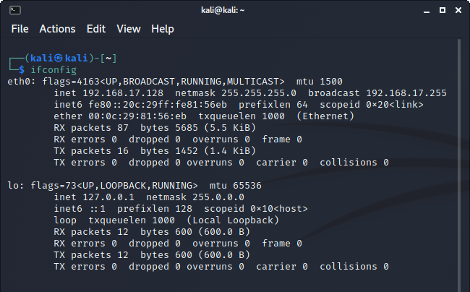

***Attacker machine ip is 192.168.17.128***

We ping the attacker machine from our victim machine (windows) to check if the attacker

machine is active and accessible from the victim machine

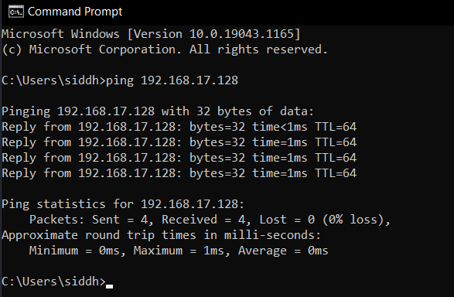

So, for performing dns spoofing attacks we are going to use ettercap tool in kali linux.

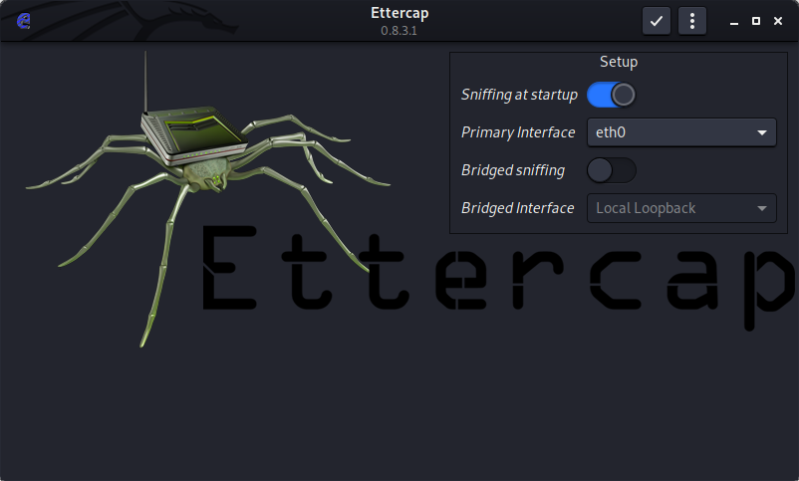

We are going to use a plugin called dns_spoof available in the ettercap tool for dns

cache poisoning.

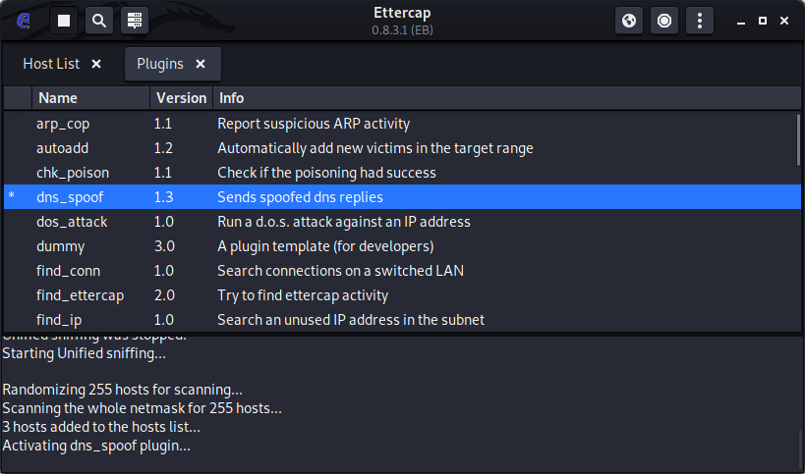

Before that we have to change the configuration of this plugin by editing file **etter.dns**

from location **/etc/ettercap** which is a host file for dns_spoof plugin in ethercap application.

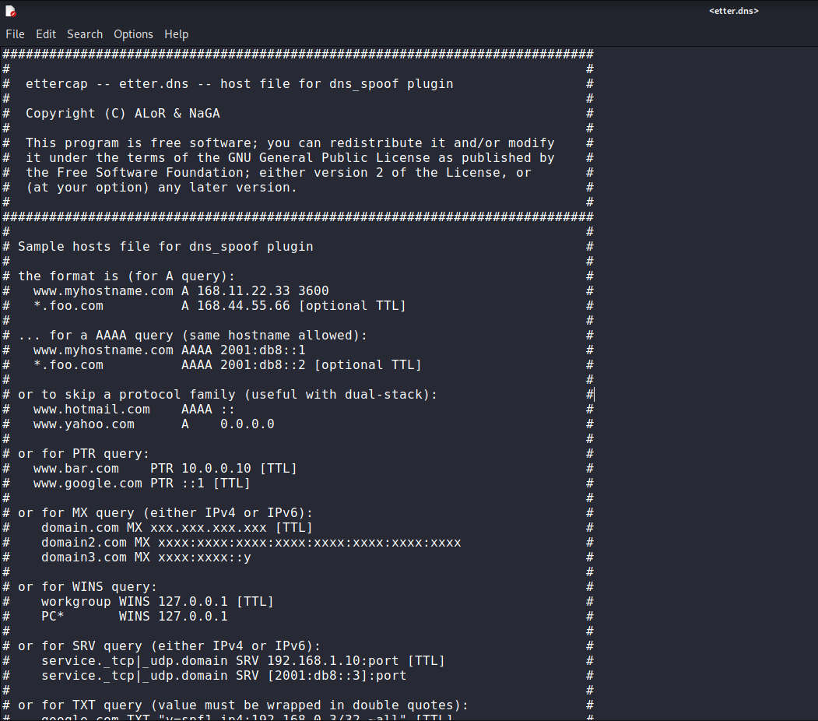

Here, we will add the domain names we would like to redirect to our local server. We

can use hosts with wildcard characters as below

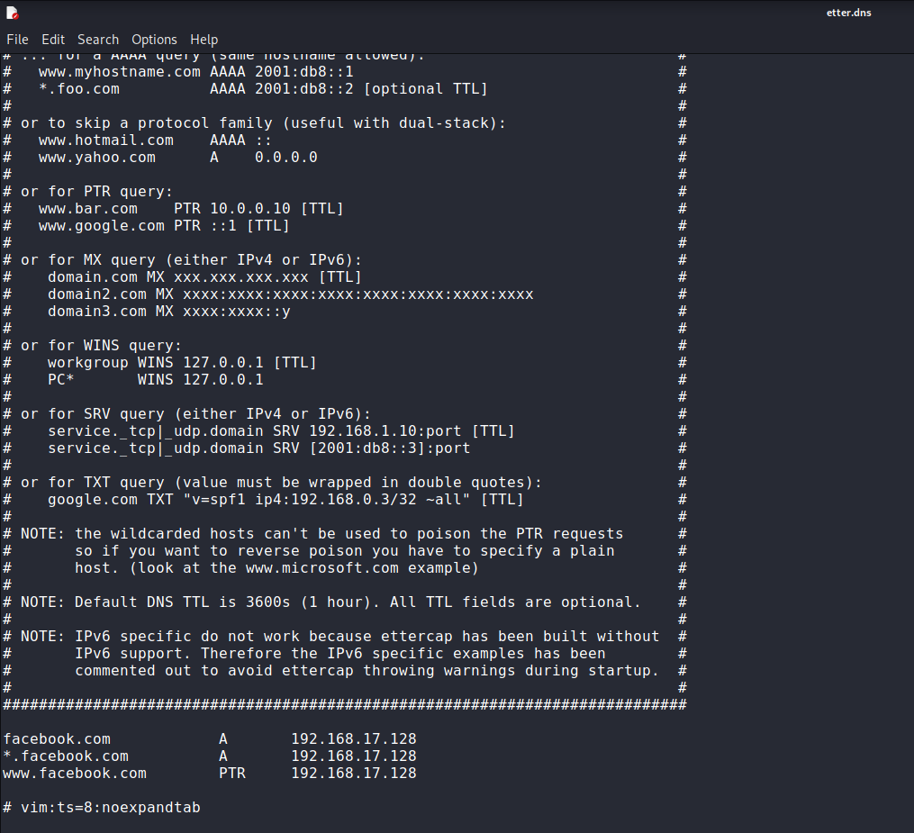

***Here we will be redirecting the data entered on facebook.com login page to our attacker machine***

Now, we need to scan for hosts in the network. It can be done as follows:

Under the Hosts tab,

➔ ***Scan for hosts***

➔ ***View host list***

From the list available,

➔ ***Add Target 1: Victim's IP***

➔ ***Add Target 2: Default gateway***

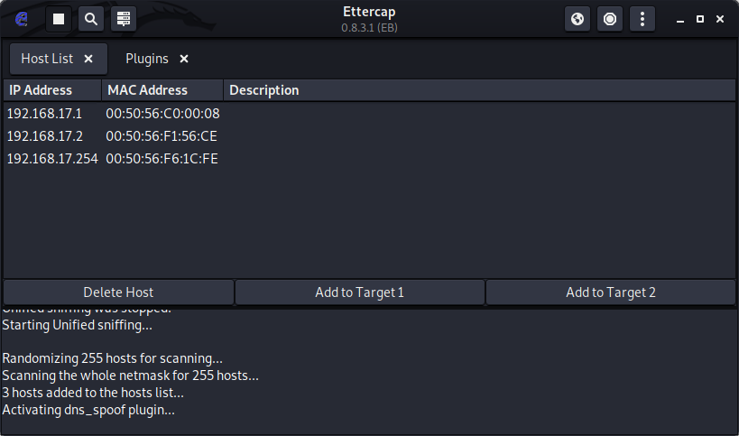

We then click on the dns_spoof plugin to activate it.



Now, we open a terminal and type **setoolkit**

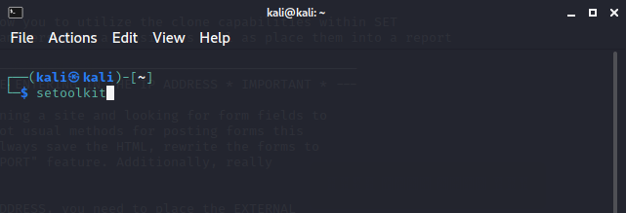

**The Social-Engineer Toolkit (SET)** was created and written by Dave Kennedy, the founder

of TrustedSec. It is an open-source Python-driven tool aimed at penetration testing around

Social-Engineering.

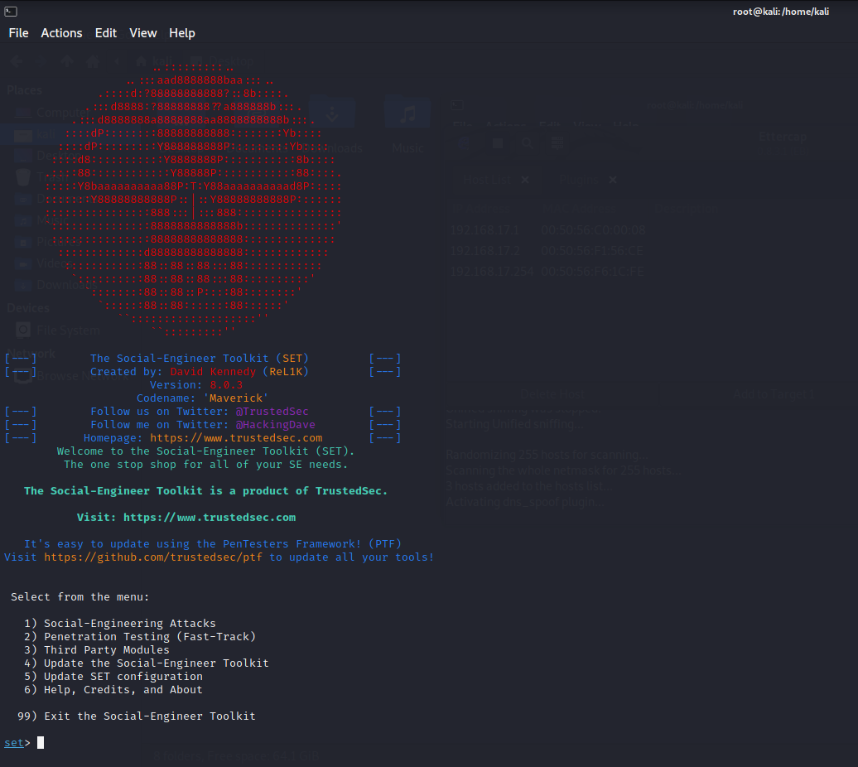

We choose appropriate options for the type of attack we are going to perform

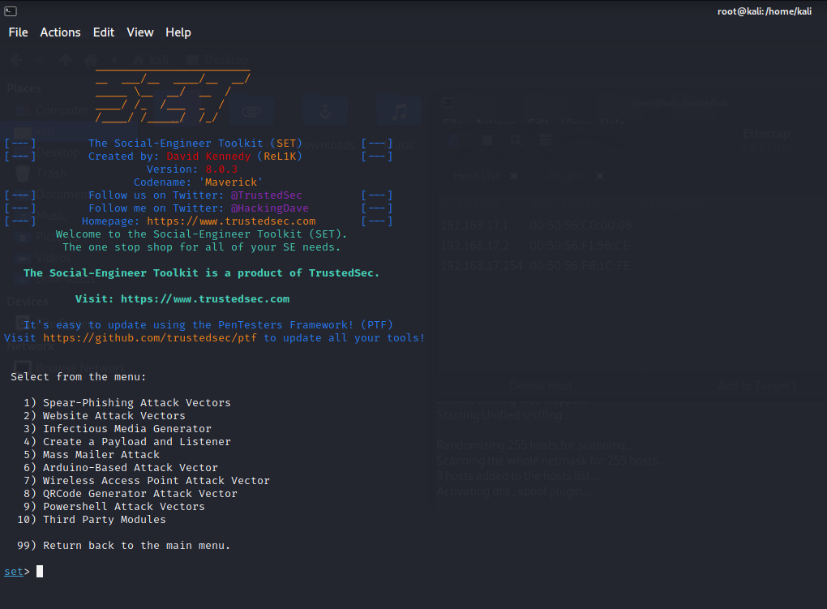

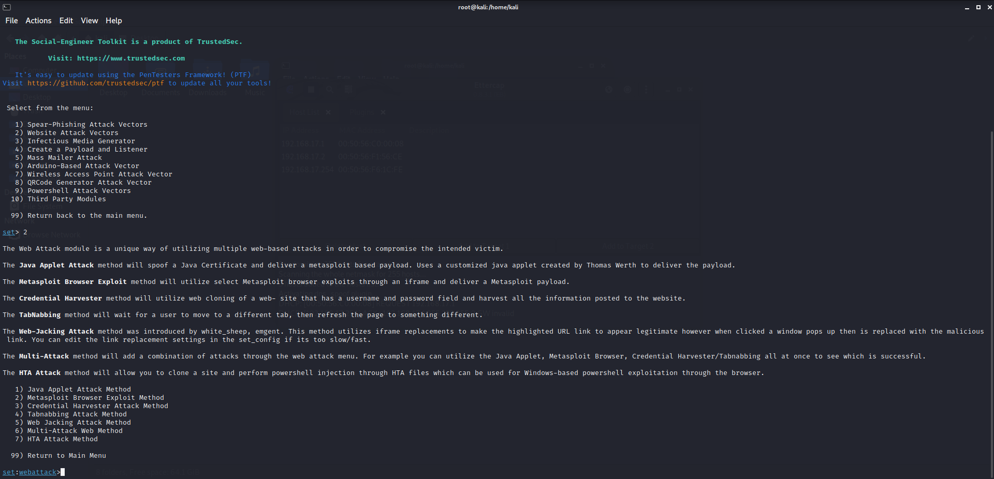

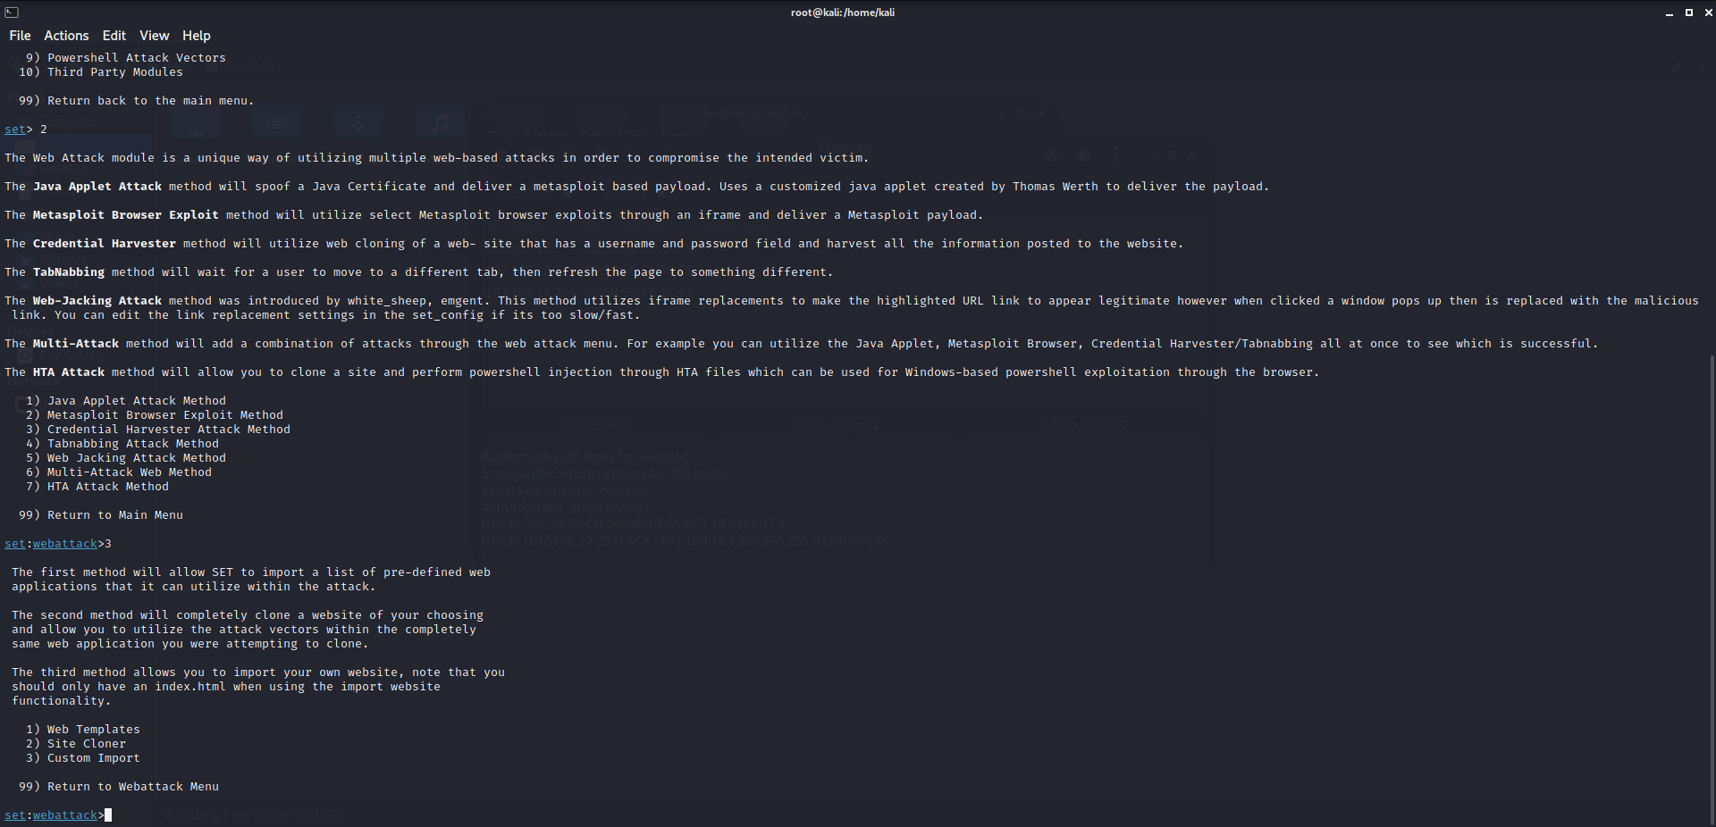

Finally, we add the ip address of the attacker machine and the url of the website to be

cloned. (In our case, it is facebook.com)

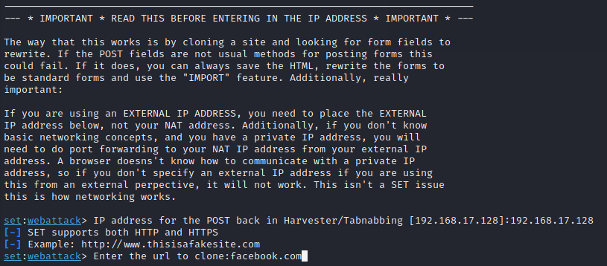

After a few minutes, our setup is ready for our attack!

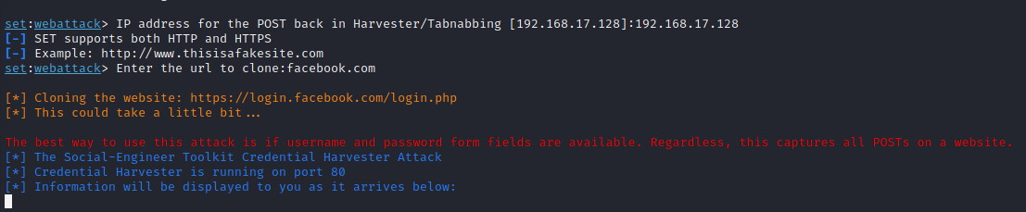

In ettercap application, we can see that www.facebook.com is spoofed and made to

redirect to attackers ip address(kali linux)

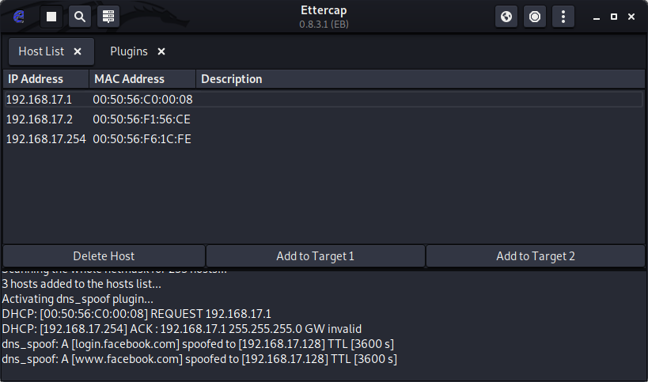

Whenever the victim tries to login facebook.com, his username and password will be

redirected to our (attacker) machine!!

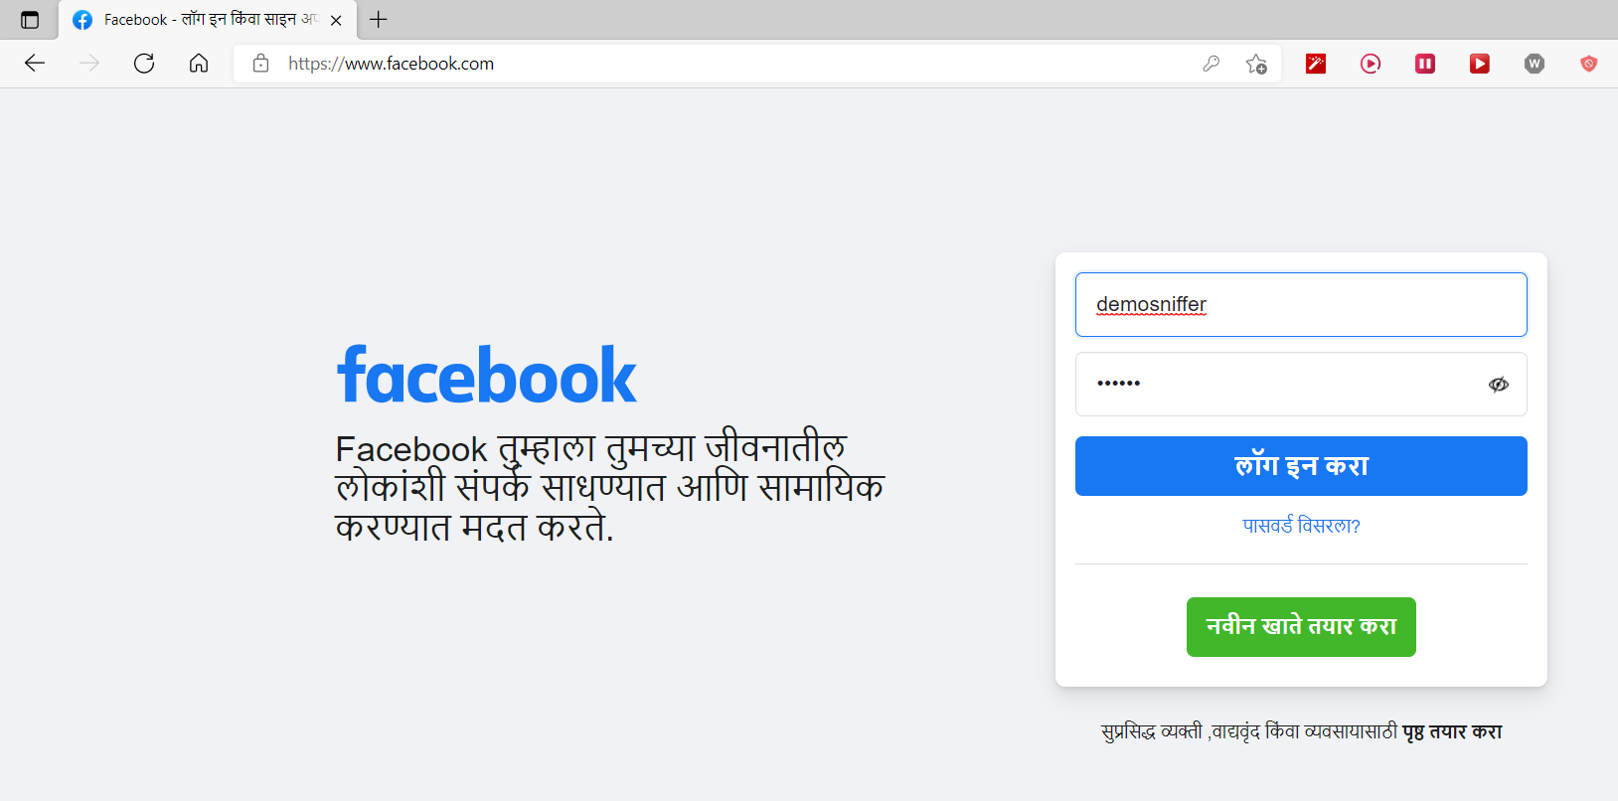

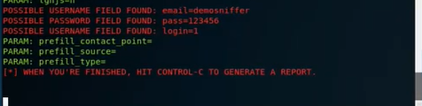

**2. TRANSPORT LAYER :**

TCP and UDP are protocols of the transport layer. The main characteristics of TCP are: reliable transmission, connection oriented, and confirmed service. This protocol is used to transmit information that requests reliable transmission, such as emails and file sharing. Characteristics of the UDP protocol are: connectionless, reduced overhead and latency and does not guarantee reliability. It is used by applications which do not require high reliability, such as video streaming, VoIP, IPTV and online games.

*Common transport layer attacks might include:*

1. **SYN FLOODING ATTACK :**

*What is SYN Flooding?*

The SYN flooding attack is a denial-of-service attack. The attacker generates a large number of half-opened TCP connections with a victim node, but never concludes the handshake to fully open the connection. There are two nodes to communicate using TCP, they should start a TCP connection using a three way handshake. The three messages exchanged during the handshake allow both nodes to absorb that the other is ready to communicate and to agree on primary sequence numbers for the conversation. During the attack, a malicious node sends a large amount of SYN packets to a victim node, spoofing the return addresses of the SYN packets. The SYN-ACK packets are sent out from the victim right after it receives the SYN packets from the attacker and then the victim waits for the reply of the ACK packet. Without receiving the ACK packets, the half-open data structure remains in the victim node.

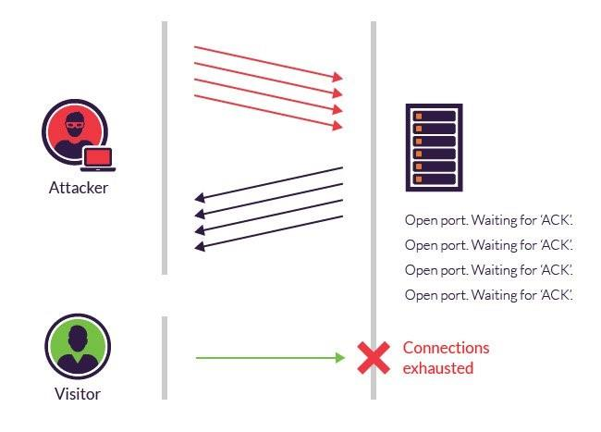

**IMPLEMENTATION :**

Attacker Machine: Kali Linux

Victim Machine: Parrot OS

Machine used to check ping results: Windows

We checked the IP address of the victim machine using the command ifconfig.

Victim machine IP address: 192.168.112.129

*● ifconfig*

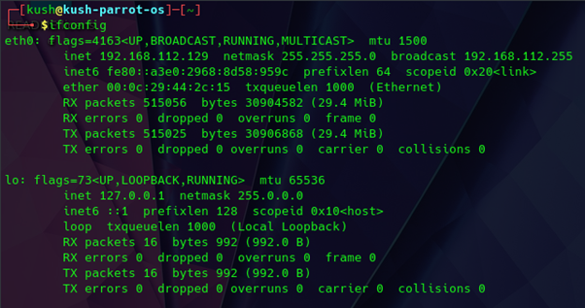

Pinging the target machine from the Windows machine using the ping command. We can see

that the response time from the target machine is very less(around 1ms).

*● ping 192.168.112.129 -n 12*

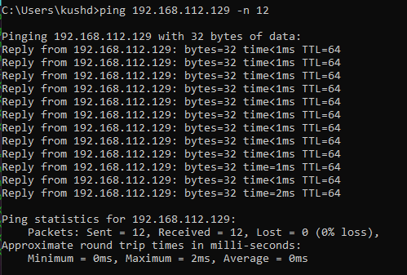

Now we flood the victim machine by making SYN requests using the hping3 tool in Kali

Linux. This will flood the target machine by making continuous SYN requests for TCP

Connection

***● hping3 -S --flood 192.168.112.129***

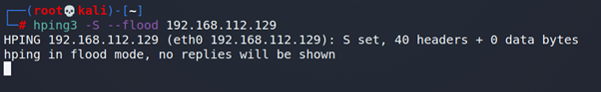

Now when we ping the target machine from the Windows machine we can see the significant delay in the response and some requests also getting timed out.

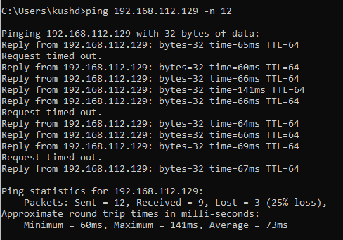

1. **TCP SESSION HIJACKING :**

**For this attack we used 3 machines.**

**Attacker Machine: Parrot OS**

**Telnet server: Kali Linux**

**Telnet client: windows**

We hijacked the TCP session in the telnet connection by retrieving the source port, sequence number and ack number of the tcp request snooped in the attacker machine using wireshark while making connection requests between client and server. Then used scapy to make a tcp request using the data retrieved to get the required file from the server. We installed the telnet on the server machine and made changes in the configuration for the host.

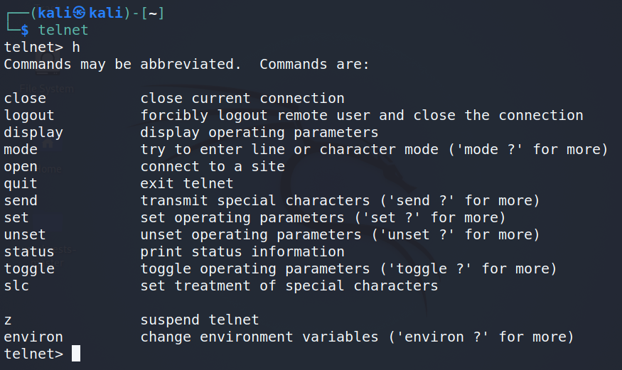

We enabled the telnet on client machine(Windows 10) by running command in

in the windows run

pkgmgr /iu:"TelnetClient"

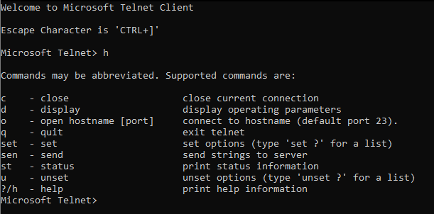

Before making the connection we started capturing packets using wireshark in the attacker machine

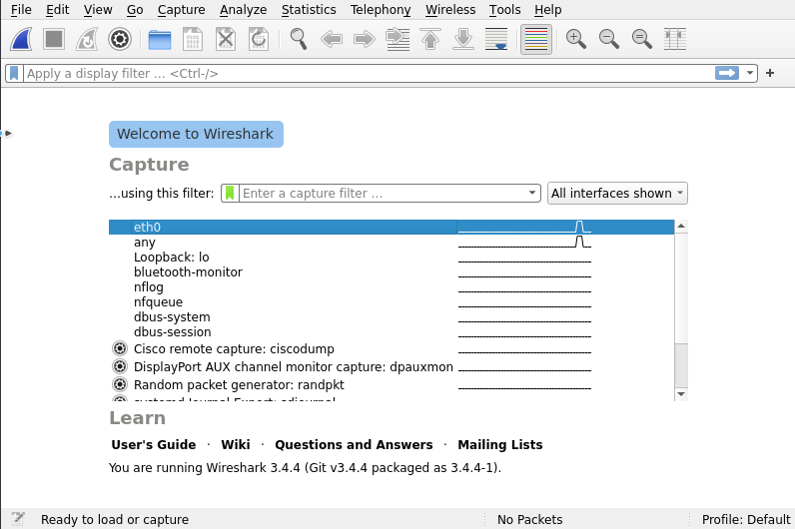

Then we made the telnet connection between client and server by running the

command

telnet <host_ip>

Then entered the login id and password of the host

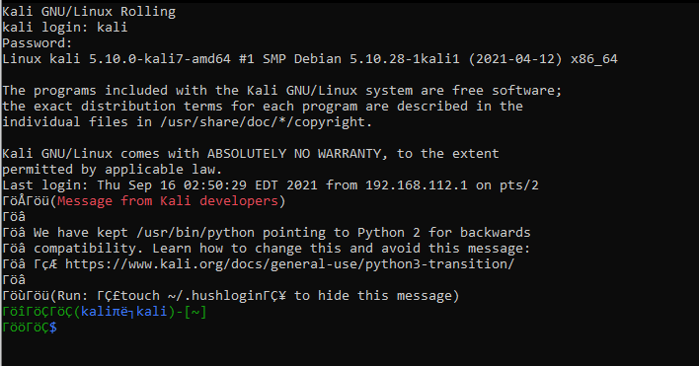

We can see the TCP requests between client and server

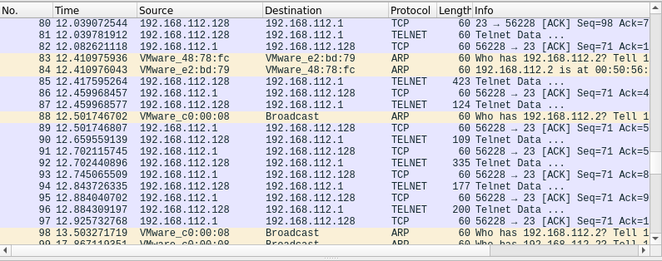

We opened the last TCP packet and noted the source port, sequence number and

ack number of the tcp request using this we made the tcp request and using

scapy we made the TCP request to retrieve the file from the server. We sent this

file output to port no 33267 where we printed the file contents.

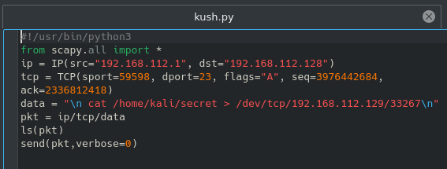

**3. NETWORK LAYER :**

The main responsibility of the network layer is to transmit the packets from the source to the destination by finding the best route, which is the route that has the lowest cost and shortest path from the source to the destination. The goal of the attacks on the Network Layer is to disrupt the path between the source and destination that is chosen from the routing protocols.

*Common network layer attacks might include:*

1. **DHCP SPOOFING :**

*What is DHCP spoofing?*

DHCP spoofing occurs when an attacker attempts to respond to DHCP requests and trying to list themselves (spoofs) as the default gateway or DNS server, hence, initiating a man in the middle attack.

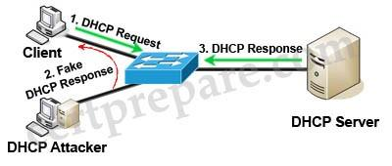

With that, it is possible that they can intercept traffic from users before forwarding to the real gateway or perform DoS by flooding the real DHCP server with request to choke ip address resources.

An attacker broadcasts a large number of DHCP REQUEST messages with spoofed source MAC addresses. If the legitimate DHCP Server in the network starts responding to all these bogus DHCP REQUEST messages, available IP Addresses in the DHCP server scope will be depleted within a very short span of time. This is known as the DHCP starvation attack.

Once the available number of IP Addresses in the DHCP server is depleted, by setting up a rogue DHCP server, the attacker can now launch a DHCP spoofing attack. The attacker can start distributing IP addresses and other TCP/IP configuration settings to the network

DHCP clients. TCP/IP configuration settings include Default Gateway and DNS Server IP addresses.

Network attackers can now replace the original legitimate Default Gateway IP Address and DNS Server IP Address with their own IP Address. Once the Default Gateway IP Address of the network devices is changed, the network clients start sending the traffic destined to outside networks to the attacker's computer. The attacker can now capture

sensitive user data and launch a man-in-the-middle attack. This is called a DHCP spoofing attack.

**IMPLEMENTATION :**

Attacker Machine: Kali Linux

Victim Machine: Parrot OS

In this attack we are going to spoof DHCP server using ettercap and assign the IP address to the victim machine from the IP pool we entered and assign random DNS server IP. We checked the IP address of the victim machine using the command ifconfig. Victim machine IP address: 192.168.112.129

*● ifconfig*

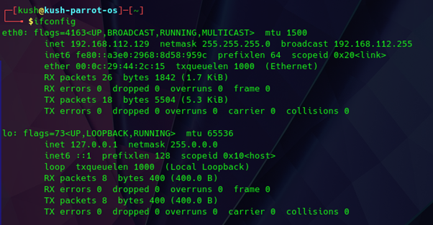

Checking victim IP address

To spoof the DHCP server we are using the ettercap tool in the kali linux. In the MITM attacks we chose the DHCP spoofing option.

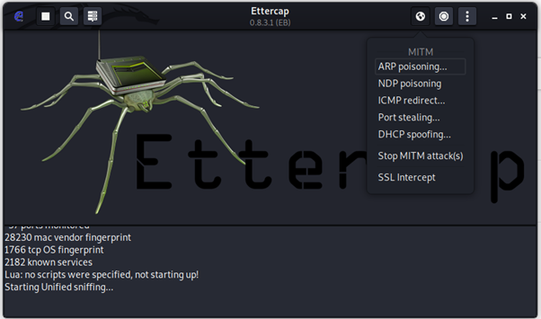

We provided the custom IP Pool, Netmask and custom DNS Server IP.

We entered:

IP Pool: 192.168.1.1-192.168.1.10

Netmask: 255.255.255.0

DNS Server IP: 4.4.4.4

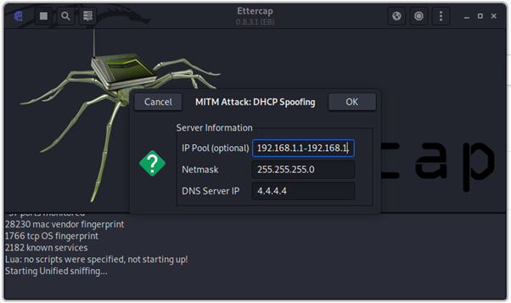

To renew the IP address on the victim machine we ran the following commands:

To reset the IP for eth0 port:

***● sudo dhclient -r eth0***

To assign new IP from DHCP server

***● sudo dhclient eth0***

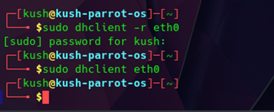

In the ettercap window we can see the new IP request from the victim and fake IP being

assigned to the victim machine from the ettercap

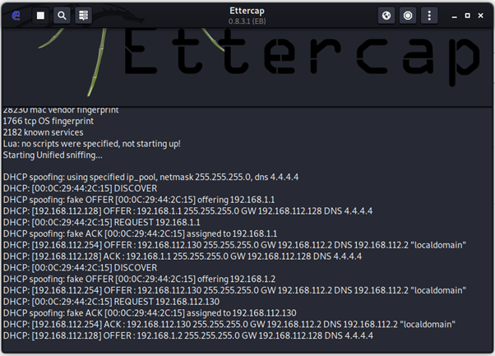

Now when we run the ***ifconfig*** command on the victim machine we can see the new IP

assigned to the victim.

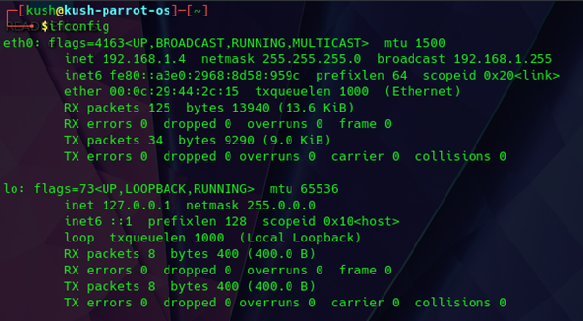

We can also see the DNS server IP 4.4.4.4 added to the DNS server IP list

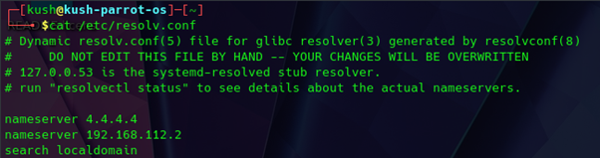

1. **IP SPOOFING :**

*What is IP spoofing?*

Spoofing is a specific type of cyber-attack in which someone attempts to use a computer, device, or network to trick other computer networks by masquerading as a legitimate entity. It's one of many tools hackers use to gain access to computers to mine them for sensitive data, turn them into zombies (computers taken over for malicious use), or launch Denial-of-Service (DoS) attacks. Of the several types of spoofing, IP spoofing is the most common.

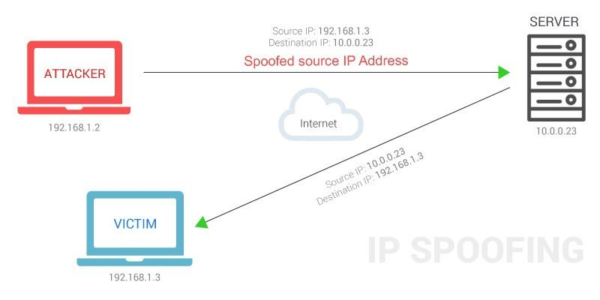

**IMPLEMENTATION :**

Attacker Machine: Kali Linux

Victim Machine: Parrot OS

We checked the IP addresses of victim machine and attacker machine using the command

ifconfig.

Attacker machine IP address: 192.168.112.128

Victim machine IP address: 192.168.112.129

*● ifconfig*

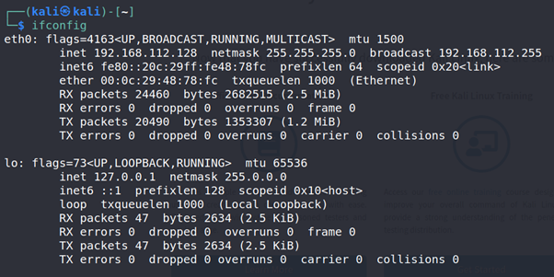

*IP address of attacker machine*

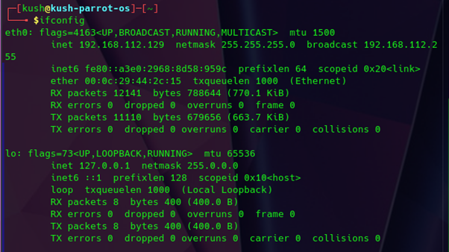

IP address of victim machine

Then we scanned the victim machine from the attacker machine by using the nmap tool. This

scans the first 1000 ports on the victim machine.

***● sudo nmap -sS 192.168.112.129***

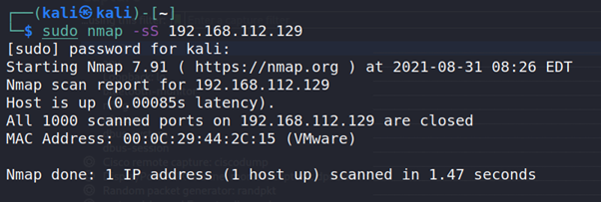

We scanned the interface and checked all requests and responses using the wireshark tool. We can see the ip addresses of the attacker and victim machine as the source and destination ip for requests and opposite for the response.

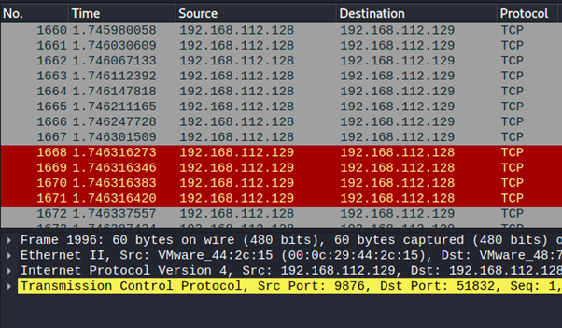

Now using the nmap tool on the attacker machine we spoofed the IP address of the attacker machine as **192.168.128.106** and scanned the victim machine using that address.

***● sudo nmap -e eth0 -S 192.168.128.106 192.168.112.129***

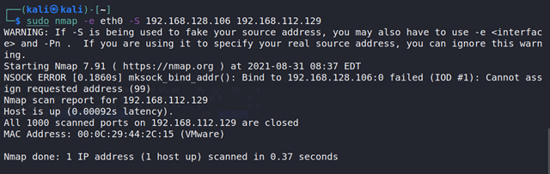

Now we can see spoofed IP of the attacker machine as the source ip for request and as the

destination ip for response in the Wireshark.

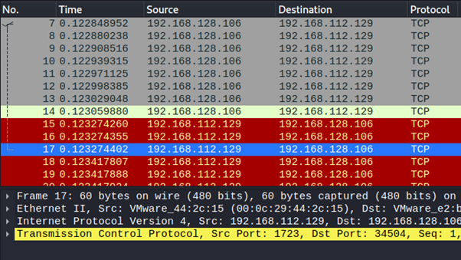

**4. DATA LAYER :**

The data link layer provides reliable transit of data across a physical link. The data link layer is concerned with physical, as opposed to logical addressing, network topology, network access, error notification, ordered delivery of frames, and flow control. Frame-level exploits and vulnerabilities include sniffing, spoofing, broadcast storms, and insecure or absent virtual LANs (VLANs, or lack of VLANs). Network interface cards (NICs) that are misconfigured or malfunctioning can cause serious problems on a network segment or the entire network. Most companies that have experienced Address Resolution Protocol (ARP) spoofing, Media Access Control (MAC) flooding or cloning, Port Stealing, Dynamic Host Configuration Protocol (DHCP) Attacks, layer 2-based broadcasting or Denial of Service Attacks have immediately focused on improving port security. They also configure their switches to limit the ports that can respond to DHCP requests, implement static ARP and install Intrusion Detection Systems (IDS).

***Common data layer attacks might include:***

1. **ARP SPOOFING / POISONING:**

ARP spoofing is a type of attack in which a malicious actor sends falsified ARP (Address Resolution Protocol) messages over a local area network. This results in the linking of an attacker’s MAC address with the IP address of a legitimate computer or server on the network. Once the attacker’s MAC address is connected to an authentic IP address, the attacker will begin receiving any data that is intended for that IP address. ARP spoofing can enable malicious parties to intercept, modify or even stop data in-transit. ARP spoofing attacks can only occur on local area networks that utilize the Address Resolution Protocol.

● The attacker opens an ARP spoofing tool and sets the tool’s IP address to match the IP subnet of a target. Examples of popular ARP spoofing software include Arpspoof, Cain & Abel, Arpoison and Ettercap.

● The attacker uses the ARP spoofing tool to scan for the IP and MAC addresses of hosts in the target’s subnet.

● The attacker chooses its target and begins sending ARP packets across the LAN that contain the attacker’s MAC address and the target’s IP address.

● As other hosts on the LAN cache the spoofed ARP packets, data that those hosts send to the victim will go to the attacker instead.

From here, the attacker can steal data or launch a more sophisticated follow-up attack. The methods recommended as measures for detecting, preventing and protecting against ARP spoofing attacks include packet filtering, avoiding trust relationships, using ARP spoofing detection softwares, cryptographic network protocols etc

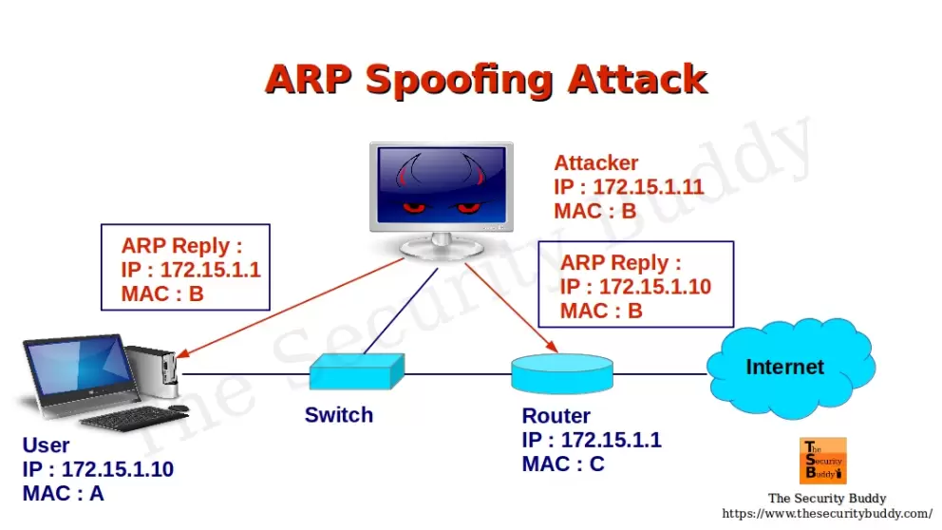

**IMPLEMENTATION :**

Initially, we determine the IP address of the victim machine and default gateway.

The victim machine used here is Windows 7.

*● ipconfig*

*● arp -a*

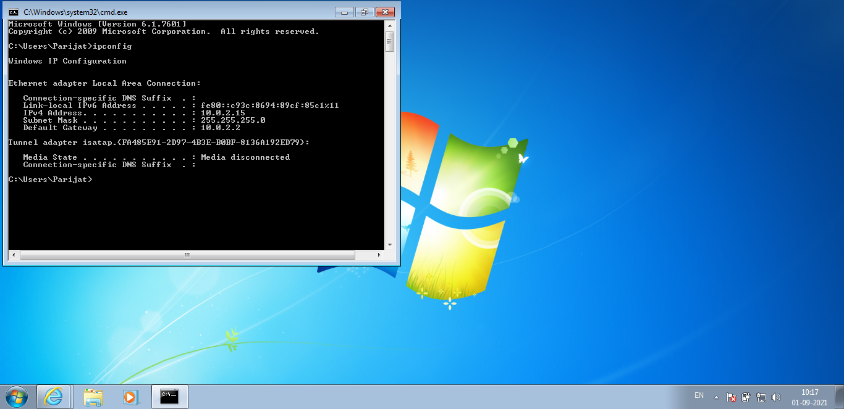

On the attacker's machine (Kali Linux), we use **"Ettercap"** to perform ARP

spoofing/poisoning.

Kali has it already installed.

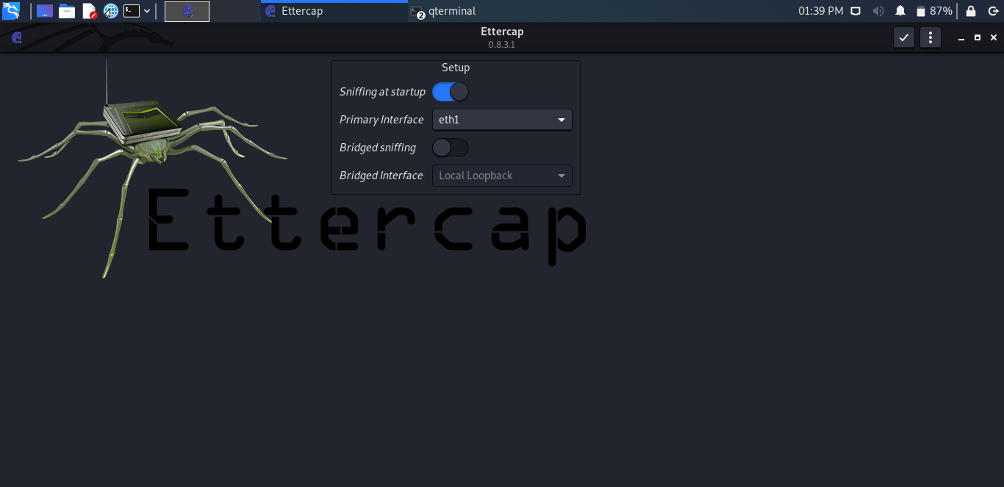

Firstly, we need to scan for hosts in the network. It can be done as follows:Under Hosts tab,

***● Scan for hosts***

***● View host list***

From the list available,

***● Add Target 1 : Victim's IP***

***● Add Target 2 : Default gateway***

Then under MITM attacks, select ARP poisoning.

The ARP spoofing attack is started

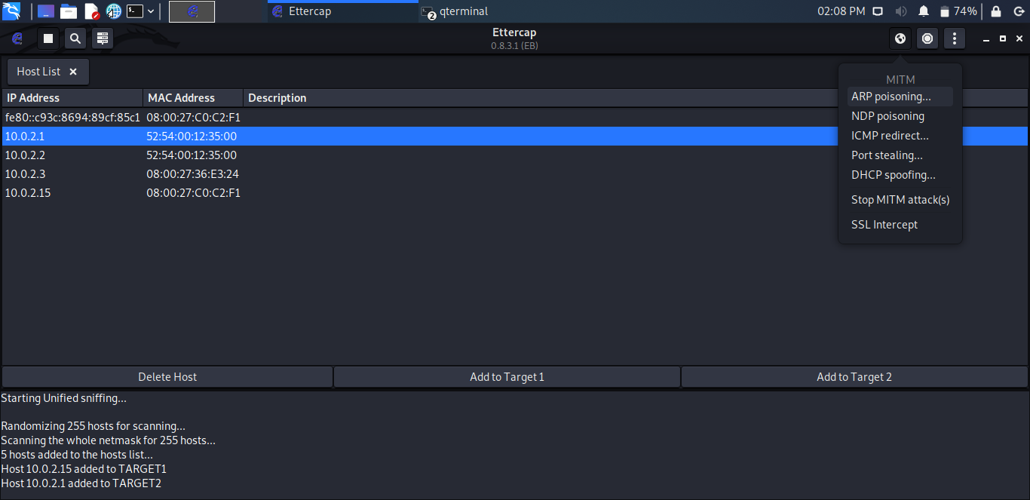

On the victim's machine, we can notice the attack using the command

***● arp -a***

Here, although the IP of the gateway does not change, the MAC address associated

with it belongs to the attacker's machine.

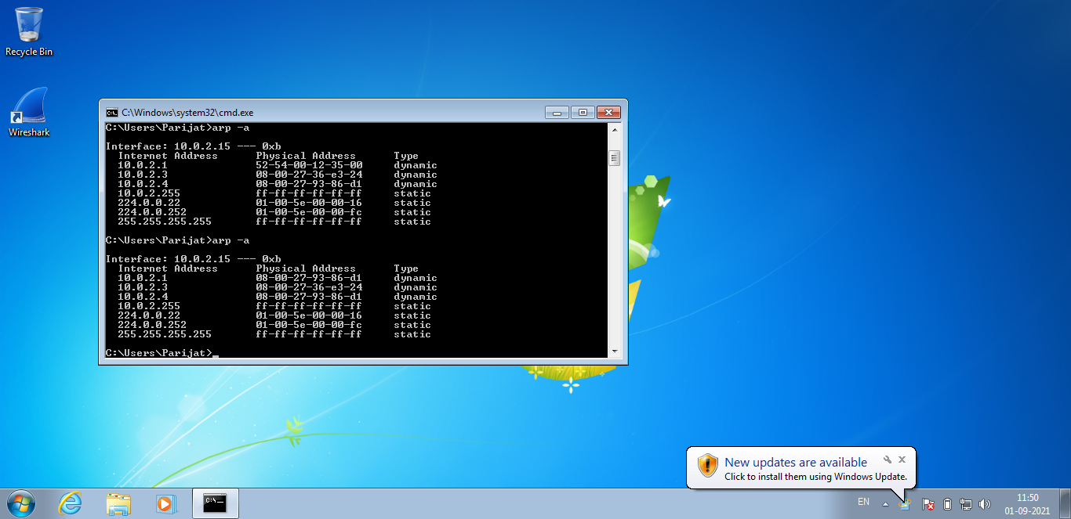

We inspect the **"Wireshark"** tool for ARP packets that can be analyzed.

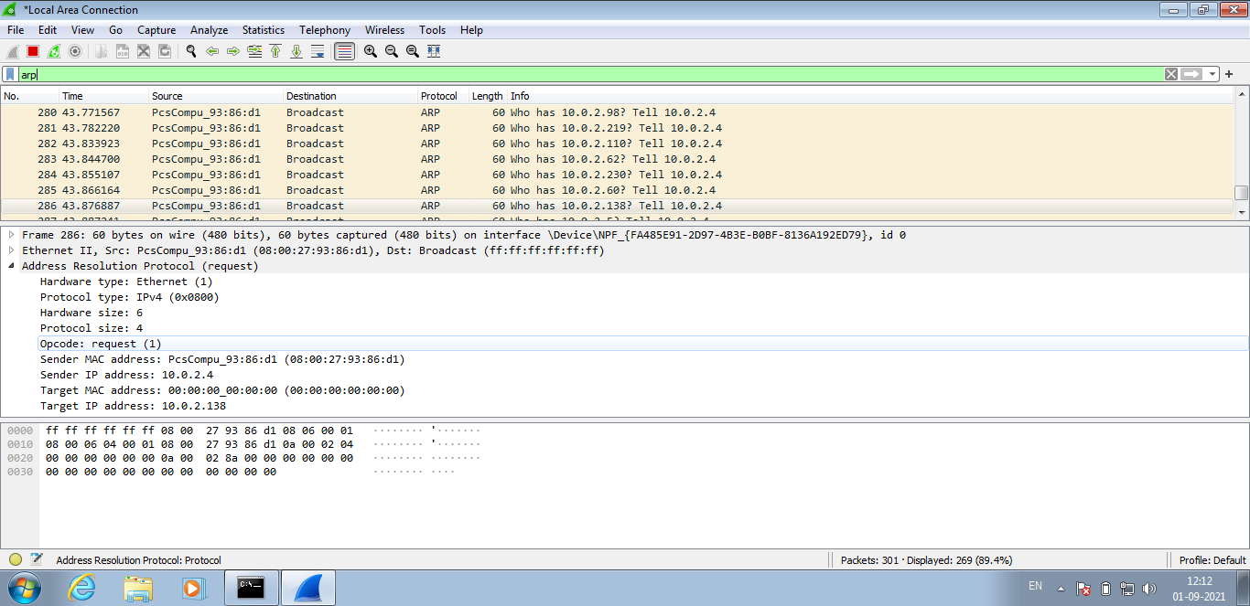

To validate the attack, we try login on the http supported website on the victim

machine. We enter username and password in the form and hit the login button.

Here, the victim doesn't realize anything and completes login.

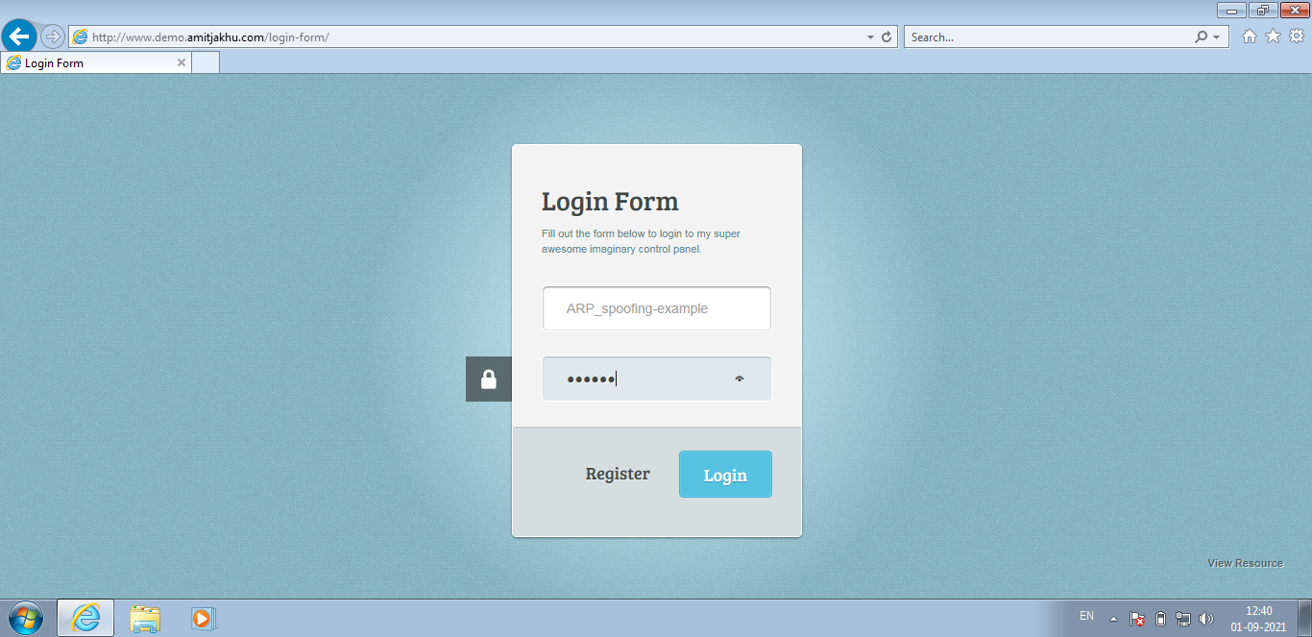

However, the details entered by the victim in the login form are available on the

console of the Ettercap tool on the attacker's machine.

Thus, the attacker gets hold of username and password using ARP spoofing.

**USERNAME : ARP_spoofing-example PASSWORD : 123456**

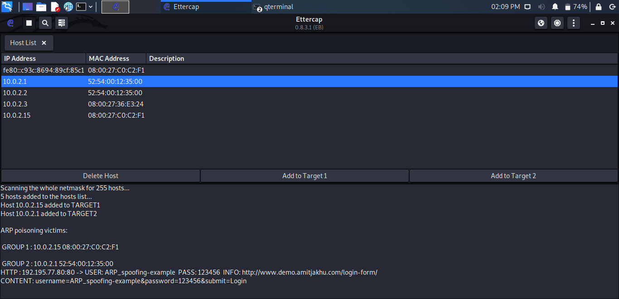

1. **MAC SPOOFING :**

MAC address spoofing attack is where the impostor or hacker hunts the network for valid and original MAC addresses and circumvents access control measures, giving the hacker the advantage to pose as one of the valid MAC addresses.

The attack wherein the hacker is also able to bypass authentication checks as he presents this as the default gateway and copies all of the data passed on to the default gateway without being identified, giving him all the important details about applications in use and end-host IP addresses.

One of the most important strategies used in MAC spoofing attacks is to mask the MAC address, also popularly known as MAC ID spoofing. Spoofing in general means the diverse methods available to control and operate the fundamental address system in different computer networks. MAC address spoofing involves a method for changing or masking the factory-assigned MAC address of a network interface on a device.

The reasons to mask or spoof the MAC address:

● Protection of privacy

● Prevention of identity threats

● Access to paid software applications

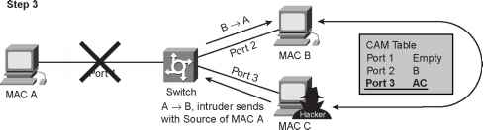

Spoofing a MAC address doesn’t go around the network and hence a network manager will still be able to scrutinize the traffic from the spoofed MAC address. An address that has been spoofed will end up showing traffic from two different sources concurrently. Another method would be a company device ostensibly connected to the network from another physical location on the network. It is also imperative to harden the system, access points, or individual machines to prevent MAC spoofing attacks.

**IMPLEMENTATION :**

The MAC address of the attacker's machine can be changed temporarily. This can help an attacker not reveal his MAC address while performing attacks.The same can be performed manually or using the "macchanger" tool.

Manual method:

To perform MAC spoofing using a manual method, the following commands can be

given. Only the root user has the permission to do so.

*● sudo ifconfig eth1 up*

*● sudo ifconfig eth1 hw ether <MAC address of choice>*

*● sudo ifconfig eth1 down*

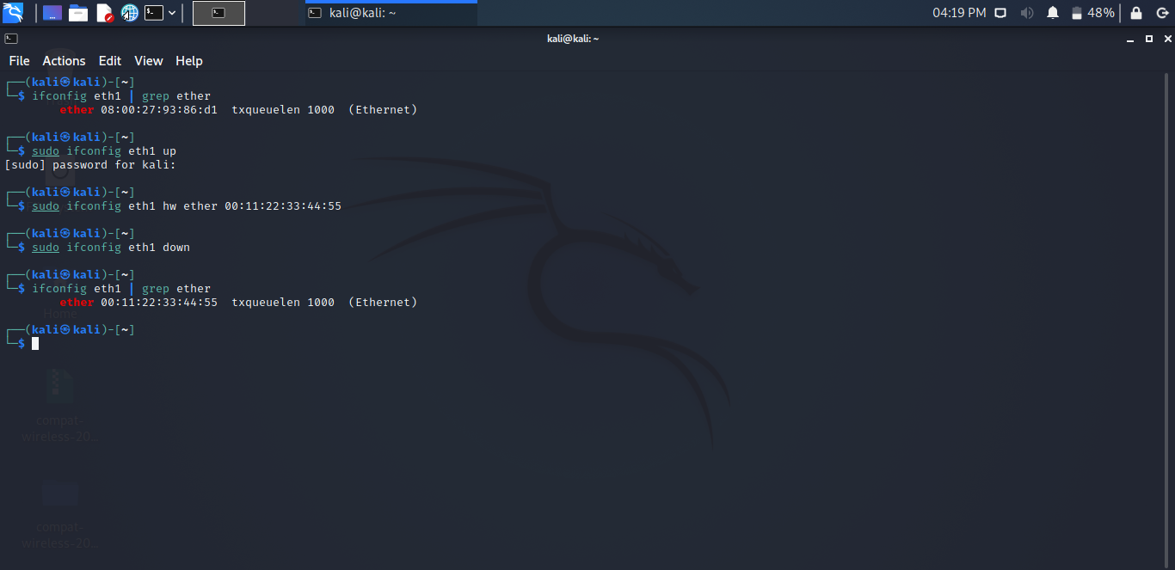

Thus, the MAC address of the choice has been assigned. It is assigned as

“00:11:22:33:44:55” here.

*● ifconfig eth1 | grep ether*

Use of macchanger:

*● macchanger --help*

To reset original MAC address,

*● sudo macchanger-p eth1*

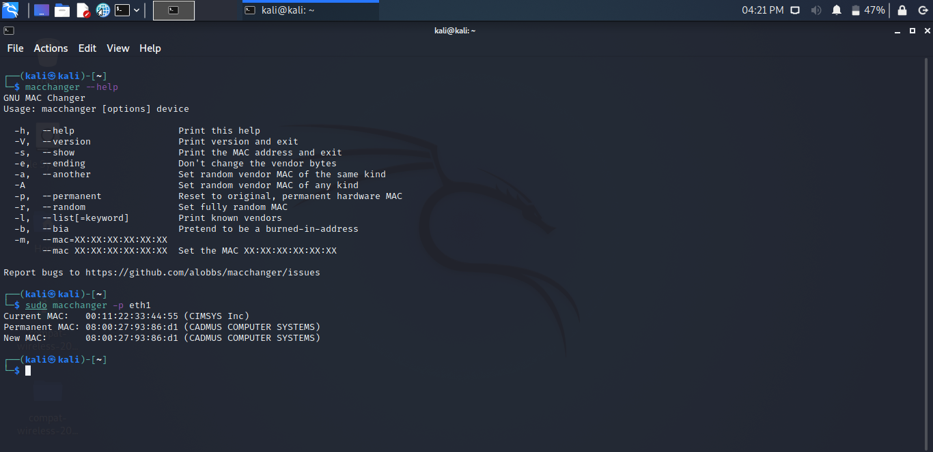

The macchanger tool can be used to allocate another MAC address as the current MAC

It has two options to do so

**-A : Set random vendor MAC of any kind**

**-r : Set fully random MAC● sudo macchanger -A eth1**

***● sudo macchanger -A eth1***

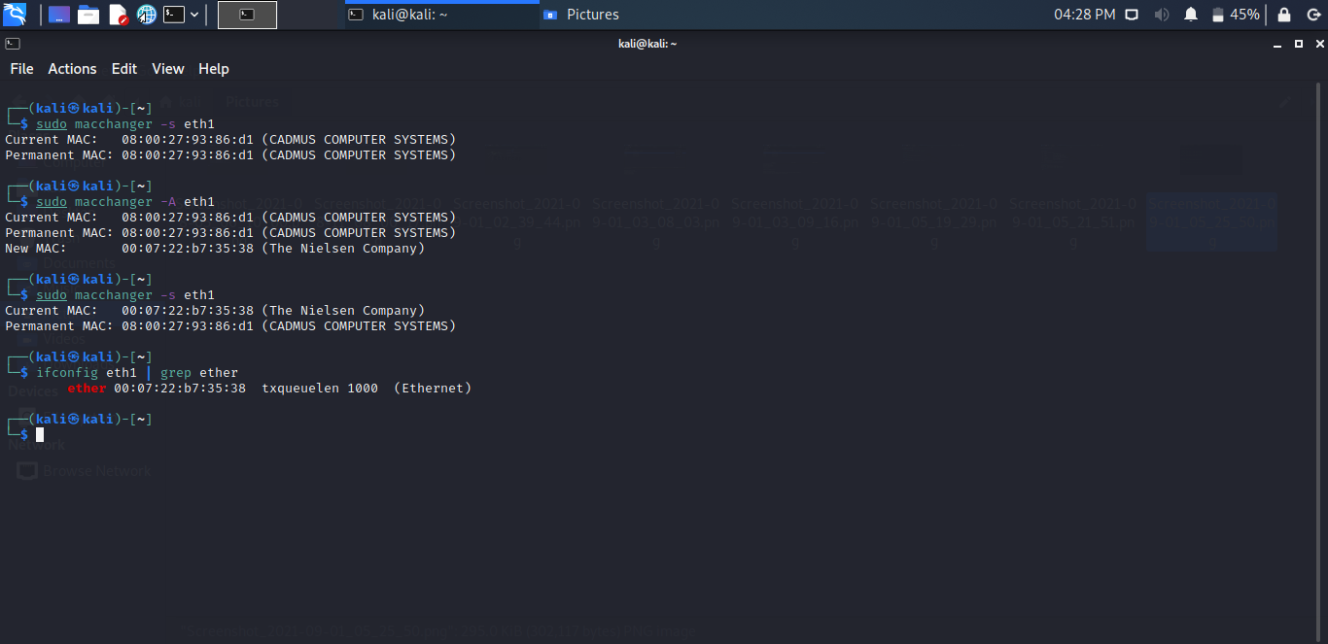

***● sudo macchanger -r eth1***

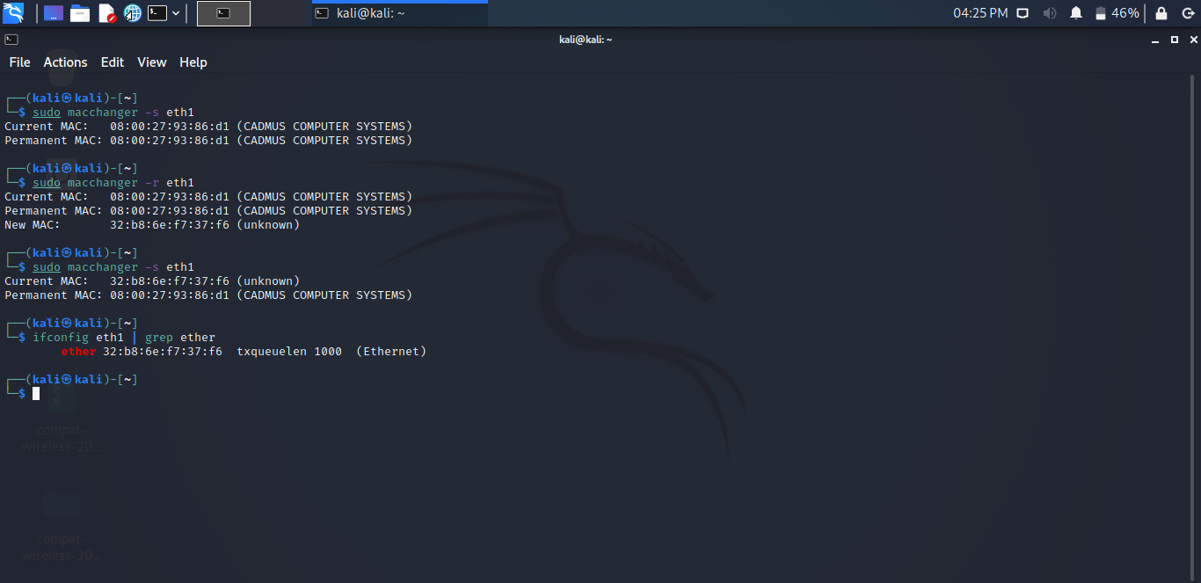

***CONCLUSION****: Thus, from this experiment we studied the various attacks*

*that place at each layer in the TCP/IP Model and perform a few attacks.*